40 Pin Connector:
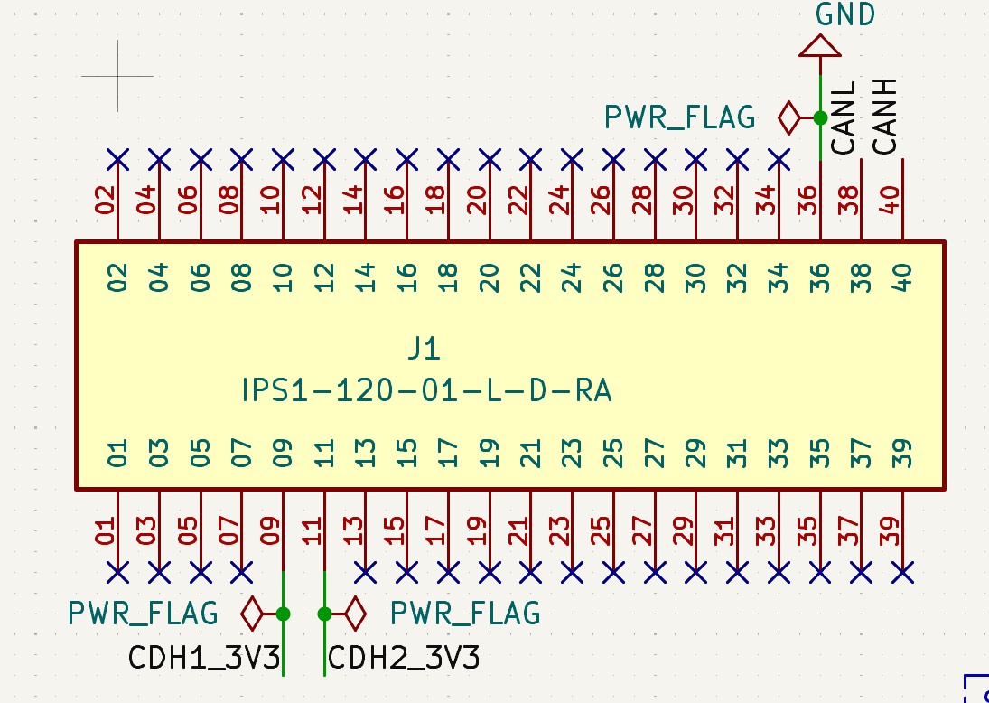
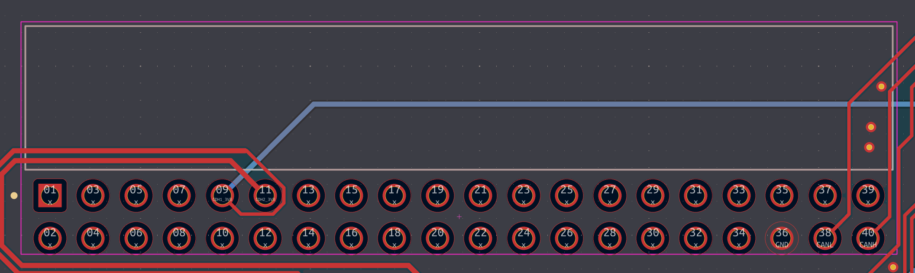
Pin # | Name | Function
9 | CDH1_3V3 | CDH 1 3.3 Voltage
11 | CDH2_3V3 | CDH 2 3.3 Voltage
36 | GND | System Ground
38 | CANL | CAN Low
40 | CANH | CAN High

SWD:
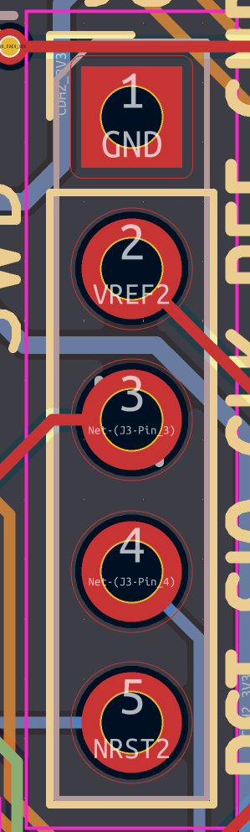
Pin # | MCU Pin # | Name | Function
1 | N/A | GND | System Ground
2 | N/A | VREF | Direct Connection to 3.3v Reference (Bypasses Safety)
3 | 49 | SWCLK | System Clock
4 | 46 | SWDIO | Data In/Out
5 | 7 | NRST | Reset. Pull low to reset chip

MCU Pinout:
Pin # | MCU # | Name | Function | Secondary Function
14 | PA0 | MCU#_FRAM3_F | FRAM 3 Fault (IN | Active HIGH) | FRAM 3 Reset (OUT | Active LOW)
15 | PA1 | MCU#_FRAM2_F | FRAM 2 Fault (IN | Active HIGH) | FRAM 2 Reset (OUT | Active LOW)
16 | PA2 | USART2_# | UART Connection between boards
17 | PA3 | USART2_# | UART Connection between boards
20 | PA4 | MCU#_FRAM1_F | FRAM 1 Fault (IN | Active HIGH) | FRAM 1 Reset (OUT | Active LOW)
21 | PA5 | MCU_MR | Mux Reset (Active | High)
22 | PA6 | MCU_SEL | MCU 2 if HIGH
23 | PA7 | NC
41 | PA8 | CAN_F | CAN Fault (IN | Active HIGH) | MCU# CAN Reset (OUT | Active LOW)
42 | PA9 | S | CAN Silent Mode (OUT | Active HIGH)
43 | PA10 | SHDN | CAN Shutdown Mode (OUT | Active HIGH)
44 | PA11 | RXD | CAN Receive (Data IN)
45 | PA12 | TXD | CAN Transmit (Data OUT)
46 | PA13 | SWDIO | Programing pin for SWD
49 | PA14 | SWCLK | Programing Pin SWD Clock
50 | PA15 | NC
26 | PB0 | NC
27 | PB1 | NC
28 | PB2 | MCU#_WD | Watchdog Pulse (OUT)
55 | PB3 | MCU#_B0 | Boot zero recovery pin
56 | PB4 | MCU#_CS3 | FRAM 3 SPI Chip Select (OUT | Active HIGH)
57 | PB5 | MCU#_WP3 | FRAM 3 Write Protection (OUT)
58 | PB6 | MCU#_I2C1_SCL | I2C1 SCL
59 | PB7 | MCU#_I2C1_SDA | I2C1 SDA
61 | PB8 | MCU#_CS2 | FRAM 2 SPI Chip Select (OUT | Active HIGH)
62 | PB9 | MCU#_WP2 | FRAM 2 Write Protection (OUT)
29 | PB10 | MCU#_CS1 | FRAM 1 SPI Chip Select (OUT | Active HIGH)
33 | PB12 | MCU#_WP1 | FRAM 1 Write Protection (OUT)
34 | PB13 | MCU#_SPI2_SCK | SPI2 SCK
35 | PB14 | MCU#_SPI2_MISO | SPI2 MISO
36 | PB15 | MCU#_SPI2_MOSI | SPI2 MOSI
2 | PC13 | LED D3 | Diag LED 3
3 | PC14 | LED D2 | Diag LED 2
4 | PC15 | LED D1 | Diag LED 1
5 | PH0 | LCK1_2 | AND_Lock Key 1 (OUT | Active HIGH)
6 | PH1 | LCK2_IN | Reset opposite MCU (OUT | Active HIGH Pulse)
60 | PH3 | LCK1_OUT | BOOT 0 Input Pin
54 | PD2 | LCK1_1 | AND_Lock Key 2 (OUT | Active HIGH)

